Justin Marucci

Assignment 4.2

04/06/2025

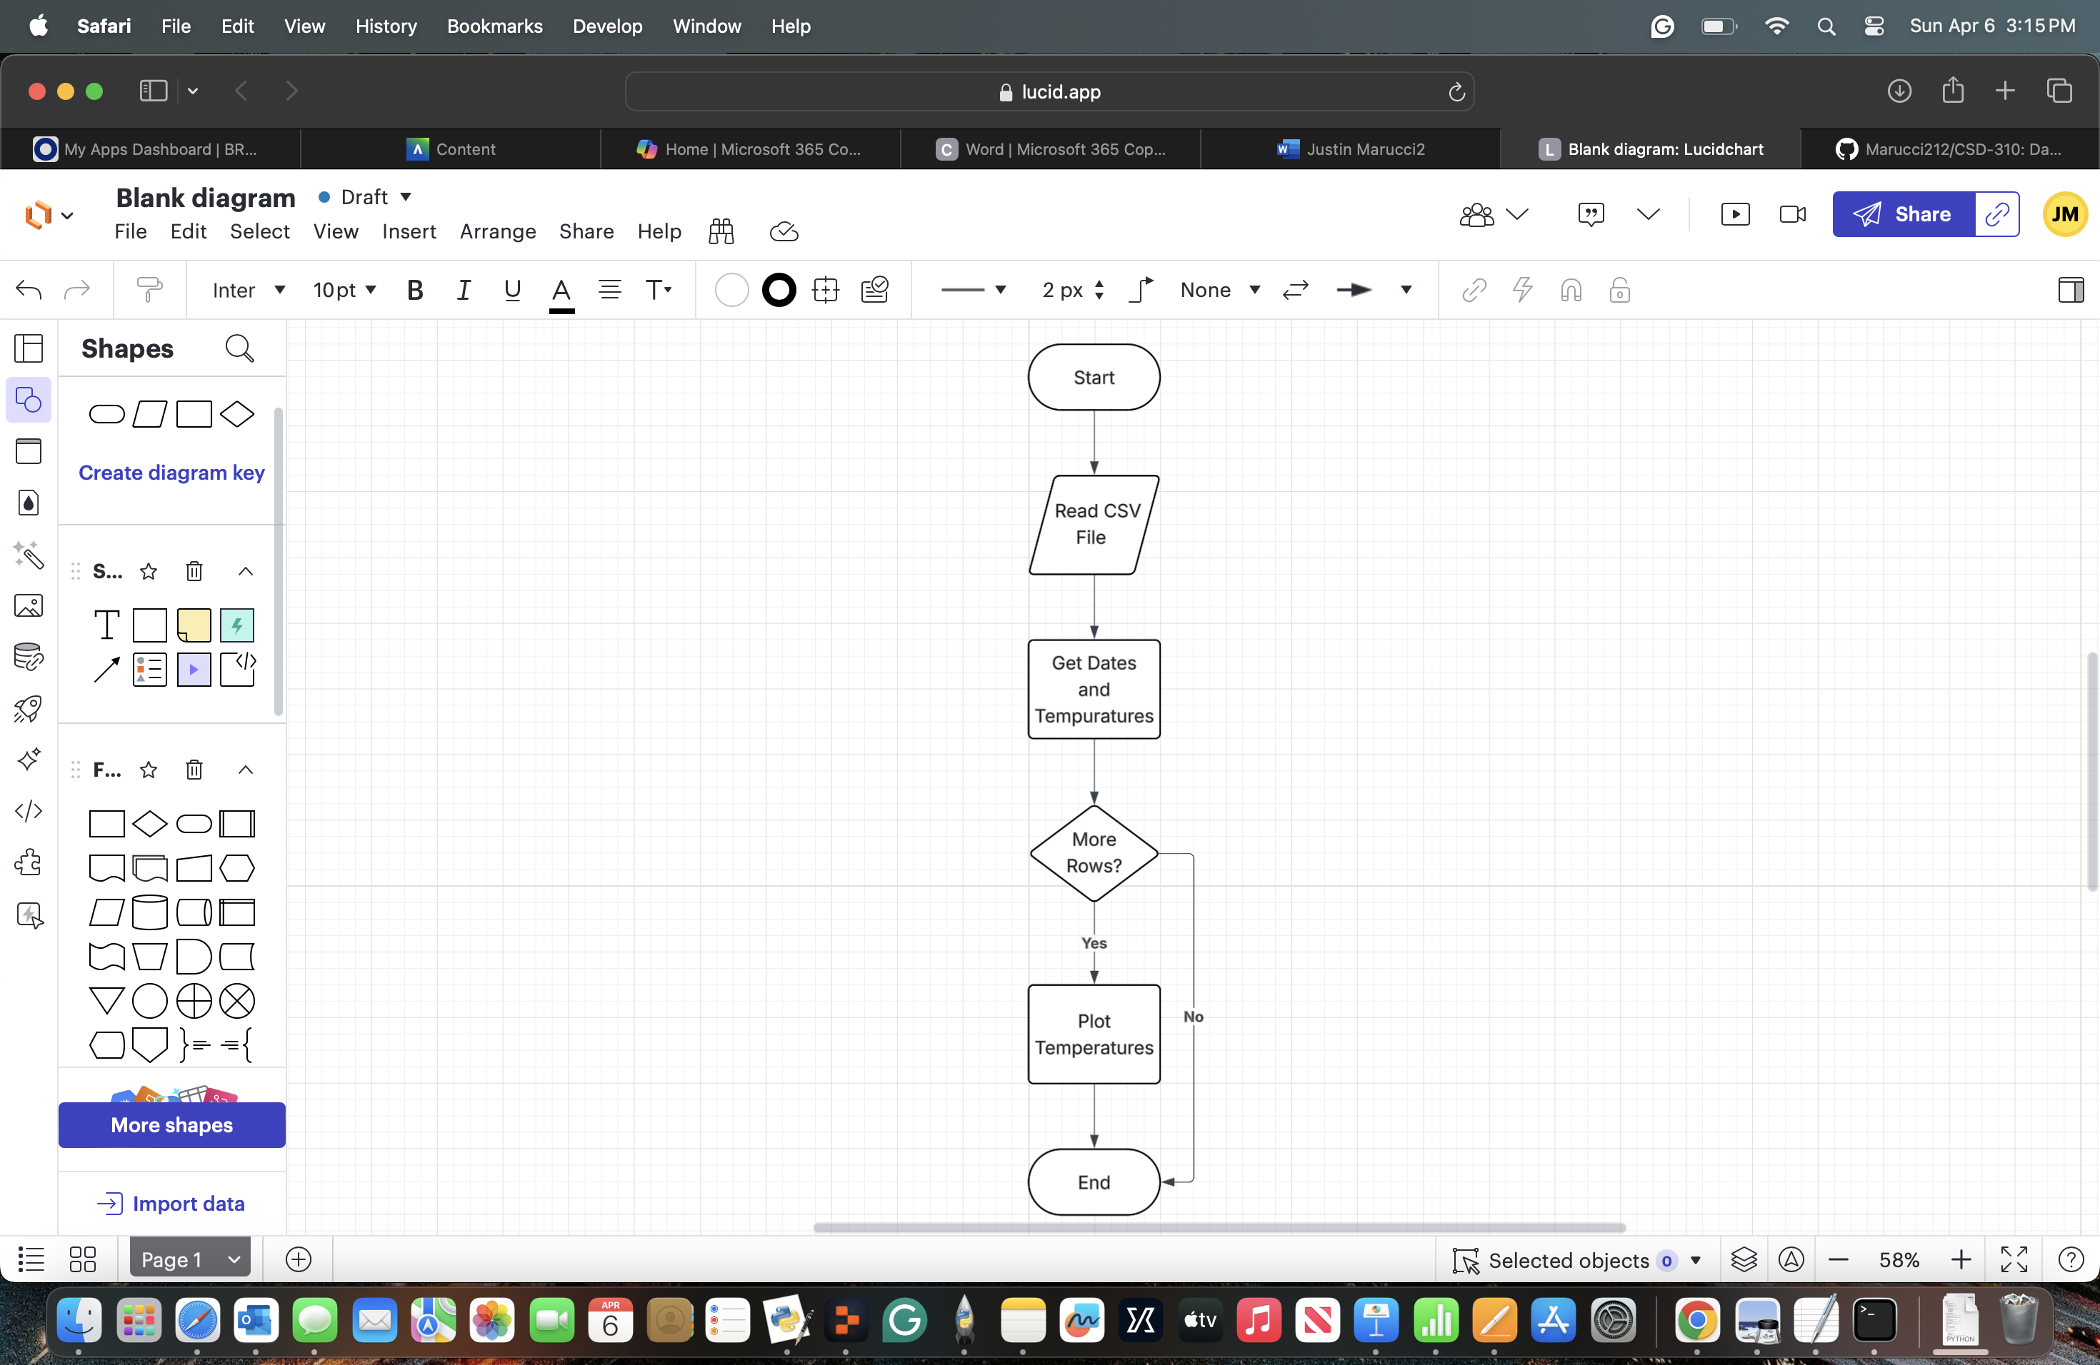

REVISED on 2nd page:

